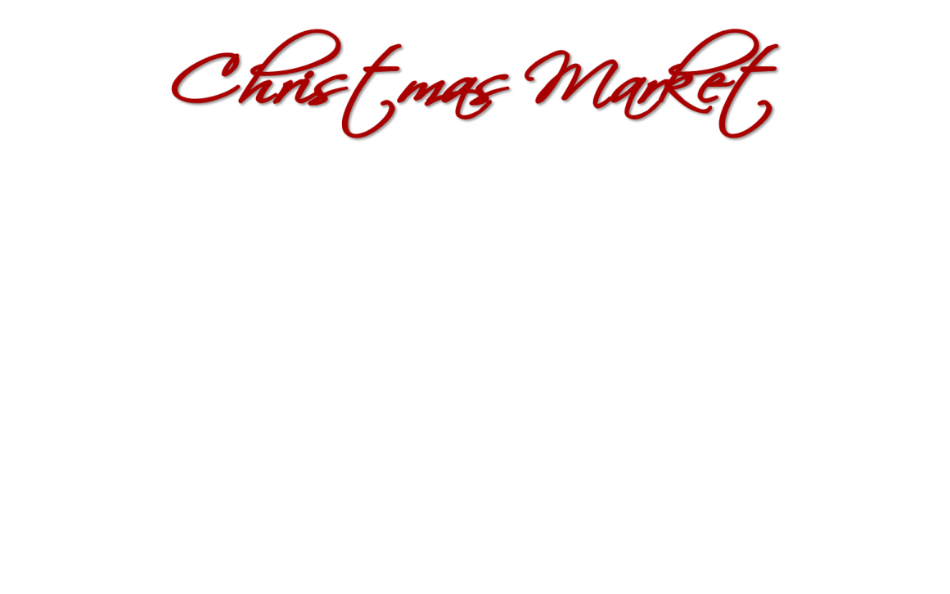

**Registration for the Fifth annual**

**Christmas Market at St. Thomas! …Dec. 6th 2025**

*

**Table Rental**: $15 per table…(*write number of tables needed on each line*)

___6ft. ____8ft. ___round

We have a limited number of tables and prefer you bring your own

Registration will be limited to the first 60 paid applicants

By signing this, I acknowledge full responsibility for all activities conducted during the Christmas Market and agree to hold St. Thomas Lutheran Church harmless and to indemnify it from any and all claims arising under this permit. I also agree to keep my table open until the end of the event (4PM)

Vendor’s signature ______________________________________________________________

**ALL SPACES ARE 8 FEET (no registration fee)**

1 space $20 ______ 2 spaces $40 ______ 3 spaces $60 ______

Are you setting up on Friday (2-8pm) _________ (yes or no)

Please enclose SPACE FEE: Make Checks payable to:

St. Thomas Lutheran Church (notation Christmas Market Fee)

**Please put your registration and check in the envelope provided.**

**Drop it in the mail or in the mailbox by the office door**

Questions? … Linda Landis 734-552-2937 or Betty Ruck 734-558-4359

**Your Name** ________________________________________________________________________

**Address:** __________________________________________________________________________

__________________________________________________________________________________

**Phone** # :__________________________________________________________________________

**Email:** ____________________________________________________________________________

**Business Name**: ____________________________________________________________________

(please make up one if you don’t have one: ex. Betty’s Candles)

**Product:** ___________________________________________________________________________