**Annual Report of the**

**Congregation**

**2023**

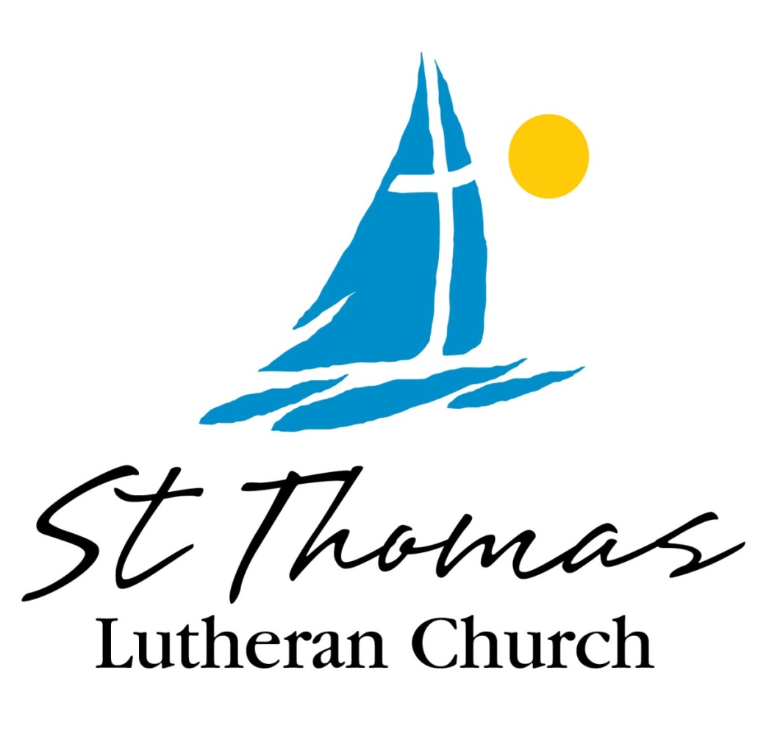

**9393 CHURCH ROAD GROSSE ILE, MI 48138**

**Phone: 734.675.0005**

**E-Mail:** [**office@stthomasgi.com**](mailto:office@stthomasgi.com)

**VISIT OUR WEBSITE: WWW.STTHOMASGI.COM**

**ST THOMAS LUTHERAN CHURCH**

**GROSSE ILE, MICHIGAN 2023**

**OFFICERS**

**PRESIDENT** Art Wahl

**VICE PRESIDENT** Sandi Loso

**SECRETARY** Nancy Graver

**TREASURER** Kent Kujala

**FINANCIAL SECRETARY** Timothy Perry

**CHURCH COUNCIL**

***SPECIAL ELECTION OF COUNCIL HELD IN 2022. TERMS LISTED BELOW.***

**TERMS EXPIRING**

**JANUARY 2025**

Anna Gartner

Sandi Loso

David Patterson

Paula Riley

Art Wahl

**TERMS EXPIRING**

**JANUARY 2026**

Justine Brozek

Wendy Brozek

Kent Kujala

Erika Kwan

David Patterson

Paula Riley

**TERMS EXPIRING**

**JANUARY 2024**

Salvatore Finazzo

Nancy Graver

**Pastor:** Kari Rinas

**Adm. Assistant:** Lisa Perry

**Booth Tech/Social Media Manager:** Betty Ruck

**Custodian:** Jackie Noles

**Director of Youth and Family Ministry:** Open

**Director of Hospitality and Property:** Linda Landis

**Director of Worship and Music:** Karen Skrocki

**Music/Property Assistant:** Jeff Kline

**Musicians:** Bob Krzeczkowski, Wendy Brozek

**2023 PASTOR’S REPORT**

St Thomas Family,

What a wonderful year this has been for our congregation! Together we have welcomed new members, celebrated baptisms, rejoiced with our young people as they received communion, grieved those in our community who have joined the Church Triumphant, and marked 60 years of ministry in amazing ways! And that does not include all of the other ways that we came together to proclaim God’s love in little and big ways this year.

St Thomas, it is such an honor to serve as your pastor. Your heart for our congregation, your love for our community, and the willingness that you show to explore where God is calling us into the future are just a few of the many ways that you make ministry and leading such a joy.

It would be impossible to say thank you to everyone who has contributed to the work of St Thomas over this past year, because truly, every one of you has given of yourselves in numerous ways. For all who volunteered and worked for our participation in the Island Fest Parade, our Peace, Love, and 60 Anniversary Festival, the Christmas Market, worship, our outreach ministries, Quilters, Bible Study, Men’s and Women’s Lunches, and everything in between, I am deeply, deeply grateful. You are doing wonderful work to promote our congregation and build relationships among our members and beyond.

We are also blessed with amazing staff who work hard to see that our needs are met. They all go above and beyond their job descriptions to help, to share God’s love, to bring us together, and who love St Thomas. It is a gift to be able to see our staff always thinking of ways to bring our community together, coming up with creative and hospitable ideas, connecting with the wider community, meeting needs beyond our walls, and serving our congregation through administrative tasks and ensuring our financial well-being.

As we started the 2023 year, our 60th anniversary year, an idea grew from a tiny seed to host a little party of sorts, outside, and to invite our neighbors to come and celebrate with us. The small idea of a bounce house, some vendors, and a little entertainment grew. And as you came together to help finance the idea, as we hit goal after goal, that tiny mustard seed grew into an incredible tree that culminated in September with entertainment, a delicious meal provided to all, music, games, crafts, vendors, a mini-car show, and so much more than I think any of us imagined when we first started. We received an incredibly generous grant from the Dearborn Downriver Plus Fund, and that, combined with the generosity of our members allowed us to “dream big”! Our festival was a great way to connect with the community, and even now continues to be something that others points out—“St Thomas! That’s the church where the big festival happened!” Or “Did you make it to their festival? It was incredible!” What a joy to celebrate!

This year also saw six of our young people complete their instruction in the Lord’s Supper. We had a wonderful day together as we learned about communion, made candleholders for mealtimes, shared stories, explored our faith and painted communion cups together. Watching these six children learn about the sacrament, the gift of incredible love that God shares with us in this meal, and watching their faith grow a little more deeply filled my own spirit. With pride, we marked the completion of their instruction by celebrating their communion with the cups they had made, each of them helping to serve our congregation. Listening to their voices declare, “The blood of Christ, shed for you,” as they felt comfortable, was a sweet proclamation of the ways that God uses each of us to share God’s love.

In October, I started a confirmation program that looks very different from the norm. In order to help our students complete a confirmation program that fits into their already-busy schedules, I wrote a confirmation program that allows students to fulfill requirements at their own pace and choosing ways to fulfill them based on their own interests and comfort. We held one of our in-person classes in early December, and plan to hold two more sessions in the remainder of the 2023-2024 academic year, with some virtual check-ins and classroom requirements. It has been fun to work with the six students that we have in the program as they continue to explore how God is moving in their lives, and to share some of the stories of our faith. I look forward to working with these students more in the year ahead, and to see how God is working through them and nurturing their faith.

I offered Ashes-to-Go on a cold, wintery Ash Wednesday, but was warmed to see folks pull up to the little pop-up tent where I was able to offer a brief prayer, confession and forgiveness, ashes, and communion to those who desired it. We had

*-1-*

a few St Thomas folks come, but also several others from the Grosse Ile community who wanted to receive ashes, but could not attend worship. I intend to offer this again this year, so watch for more information with times to come!

We have seen our congregation continue to grow in energy and commitment to this faith community and to seeking God’s intended future for us. As we look into the year ahead, we are turning our focus towards our Capital Campaign as we try to “Fill the Ship”! We are working towards our goal of paying down our mortgage before our interest rate changes in October, with the hope of better securing our financial position, and in doing so, our future. Achieving this goal will allow us to find greater financial stability and open more possibilities for ministry in the years to come.

We have already seen St Thomas folks share generously towards this goal, having already received $5375 towards our goal of $170k. We will share in more detail at our Annual Meeting the specifics of our goal, the two phases that we see (the first being towards our mortgage, with an end date of September 2024, and the second phase going towards funds for furnace repair/replacement and technology updates as needed). I am excited for the opportunities that will be presented as we approach our goal and look ahead to our next 60 years of ministry on Grosse Ile! Every contribution towards this goal will make an impact. Thank you to all who have given towards this goal already, and if you have not given to the campaign yet, we ask you to prayerfully consider doing so. All monies that come in for this campaign will go towards paying down the remaining principle on the mortgage.

In 2024, I am also anticipating making a few minor changes to our services for the season of Lent. My plan is, instead of trying to participate in the Downriver mid-week services that move from church to church, we will hold our own services here at St Thomas. Specific plans are still being worked through, but the broad-strokes vision is that during Lent, Thursday evening services will continue to be a full service, but with a different sermon or message than the sermons for Sunday. Thursday evenings will have a theme for the season of Lent, while Sundays will continue to follow the Revised Common Lectionary readings. This way, Thursday evening worshipers will continue to have a full service, but those who typically attend Sundays will have a unique service to attend during Lent as we prepare our hearts and spirits for Holy Week. We will add a simple gathering of soup and bread before each service, but will only be looking for one or two volunteers to provide something each week. I will share a little more detail during our annual meeting as I have specifics more finalized. I hope that, whether you normally worship on Thursdays or Sundays, you will make time in your week to come to at least some of these services and join in some time of nourishment and fellowship.

Additionally, I am planning for our final Thursday evening service during the season of Lent, March 21, to be a service of healing. During this service, there will be time for quiet reflection and meditation, communion, and a special time to receive individual prayer and anointing for those who wish to receive it, at the conclusion of the service. This additional prayer time will be an opportunity to pray for healing of body, mind, or spirit, and can be a powerful connection of faith and expression of need.

Other plans that we are working toward in 2024 include: Vacation Bible School (and we will need your help to make it happen!); continuing to assist with ChristNet to feed and house those who are experiencing homelessness; opportunities to nurture our faith through study and gatherings; and more! Help us share the news in our community that exciting things are happening at St Thomas, and we want others to come and see, and have God’s love in Jesus Christ extended to them!

I am truly excited for the year ahead and all the ways that we will continue to share God’s love in our community and the world. Entering into this year, I also leave you with a challenge: to extend an invitation to at least three people to come and see what we are up to at St Thomas. It could be an invitation to a worship service or to an event that we are planning. It might be an invitation to a neighbor with VBS-aged children to bring them when the time comes. It could be an invitation for a friend with a particular skill to help out on a project around the church. It could be an invitation to someone who is a St Thomas person that you have not seen in a while or a friend or neighbor who has never been to St Thomas - or to a church! But I challenge you to extend the invitation, to follow up on it, and to encourage them to come with you and see some of the exciting things we are doing. Invite them to see the ways that we are working to share God’s love and to proclaim the Good News that Jesus Christ offers to everyone. We are doing great work together, Beloveds, and I hope you want others to know and see it, just as much as I do! Thank you for an incredible year, and for what is still to come!

In Christ,

Pastor Kari Rinas

*-2-*

**2023 COUNCIL REPORT**

Members of St. Thomas Lutheran Church,

It has been my privilege and honor to serve as Council President again in 2023. We have had such a great year of community, growth, celebration, and preparation for the years to come. We thank both Nancy Graver and Dr. Salvo Finazzo for their dedication and work on St. Thomas’ behalf while serving on Council. Both Nancy and Sal have decided to end their tenure on Council as of January 2024. They both were instrumental in the work we have done since May of 2022, they both are dedicated to continue to be a part of our congregation and will continue to work for our church going forward. Church Council will have 9 people serving in 2024 (our Constitution indicated number) with elections for 5 positions next January, each to serve 3-year terms. The other 4 positions will be elected similarly in January 2027.

In September we had a 60th Anniversary Celebration that was well-attended and exceeded all expectations. The free-will donation that day raised $600 that was donated directly to local food pantries in the Downriver area. Over this past year we welcomed several new members, had an increase in pledges for 2024 of over 25%, we had six children receive their First Communion training, we have six others that have begun their Confirmation instruction, we are streaming services live and once again had a very successful Christmas Market. Our church has established operations that are solid and will sustain us going forward. We have an engaged Mutual Ministry committee, a Stewardship Committee that is very active with investments/budget and the Capital Campaign. Although we still can use some people to help, we have ushers at services, communion assistants each week, readers each week, a full operating staff, and we continue to offer a more personal Thursday evening worship service. Church Council meets once a month on a Sunday after church service, you are welcome to attend, the agenda and minutes are available in the office.

In the coming year we have made it a goal of Council to gain more volunteers to help with all the aspects of St. Thomas’ operation, including the worship areas mentioned and several other areas of need. Our Evangelism committee has four council members working on various aspects of outreach and making connections with members and our community. We continue to be supportive and instrumental in ChristNet, among other ministries. We have a Sunday School program with a curriculum and volunteer teachers. Worship and Music is looking to add a few more voices and maybe incorporate some added musicians. We can use assistance with technology, both streaming and in the technology booth. Property and Maintenance has been divided into two basic functional areas: “Interior” and “exterior“, both areas need people to assist with various items and tasks. (We do have staff that cover the basics, but they need “hands” to complete many items through the year.) You are encouraged to pray and think about ways you can contribute your skills, talents, and energy this year to St. Thomas in one or more of these vital areas. Pastor Kari, or any of us on Council, would be thrilled to talk with you more about how you can be a part of this work.

With that being said, there is still a lot of work to do, and many ways we can demonstrate our Christian love in the community and among our congregation. Although the term is not often attached to churches, I feel like everyone “is a stake holder - it’s your church, this is your footprint of faith in action”. Prayerfully consider how God may be directing you to help.

Finally, I ask you to continue to pray for this congregation, Pastor Kari, and the work God is calling us to do in 2024.

**Art Wahl Council President St. Thomas Lutheran Church, Grosse Ile**

*-3-*



**2023 STATISTICAL REPORT**

*-4-*

**2023 TREASURER’S REPORT**

Year in Review – 2023

St Thomas was blessed to have received $174,040 for ongoing ministries through the faithful and generous giving of our congregational members.

The mortgage principle was reduced by $12,612. The remaining balance on the mortgage is $177,736.

Submitted by: Kent Kujala

*-5-*

**2024 PROPOSED BUDGET**



***-6-***

 *-6-*

**DECEMBER 2023 BALANCE SHEET**

*-7-*

*-7-*



**2023 DECEMBER PROFIT AND LOSS**

*-8-*

**2023 LADIES’ GROUP**

The year 2023 saw the beginning of a return to activities for the women’s groups that gather at St. Thomas Lutheran Church.

* The Ladies’ Lunch Group continued monthly gatherings at Ramsey’s Restaurant in Trenton on the second Wednesday of the month.
* A large number of St. Thomas women made keepsake Christmas tree ornaments distributed at the Christmas Eve service for 100 attendees.
* A large donation of needed items was collected and distributed to the Michigan Humane Society and Bellaire Senior Living Facility in Riverview.
* Coffee hour was continued this year after Sunday worship services. The coffee hours were hosted by various members or by our perennial hostess, **Linda Landis**.
* **Linda Landis continues to serve as Hospitality/Property Director.** We had a sizable number of special events this year beautifully organized by Linda. We had a good attendance and a huge assortment of soups at the Downriver Cluster Ash Wednesday service sponsored at St. Thomas, a magnificent Easter breakfast, annual Aller Scholarship Recognition Reception, a well-attended 60th Anniversary of St. Thomas potluck, a Pledges and Pies event during our Stewardship campaign, and an enlarged Christmas Market in December.

**2023 MEN’S GROUP**

The Men’s Group of St. Thomas also continued its monthly lunches during 2023. The group continued meeting at Sully’s BBQ every second Thursday of the month. Attendance averaged around 5 men.

*-9-*

**2023 PROPERTY REPORT**

**2023 Upgrades, Enhancements and Improvements**:

* The 60th Year Anniversary of St. Thomas (happily handled)
* Third Annual Christmas Market held successfully
* New furnace in sacristy
* Lowered air-duct channel and installed new sump-pump
* Installed new security cameras
* All new LED light bulbs in sanctuary
* Replaced timer for outside lights
* New filters in educational wing registers
* Repair of sanctuary furnace
* Kick-plate installed in new coffee bar
* Gutters cleaned
* Trimming of all trees and shrubs
* Clean-out and repair of grease drain in kitchen
* Carpet in both offices cleaned
* Windows cleaned
* Dumpster door repaired
* Chairs and tables cleaned
* Two clean-up days held by members, getting a lot done
* Mulch added by many hands - along with the edging, raking, picking-up, power-washing, painting around the exterior of church and Memorial Garden

 I would like to take this opportunity to give great thanks for the generous supplies and to the many donors who have graciously helped me through the year. It is your time, skills, talents, and funding that have made all of these accomplishments possible.

Gratefully Yours,

Linda L. Landis

*-10-*

**2023 ST. THOMAS WELCA REPORT**

**WOMEN OF THE EVANGELICAL CHURCH IN AMERICA**

*WELCA purpose statement: As a community of women created in the image of God, called to discipleship in Jesus Christ and empowered by the Holy Spirit, we commit ourselves to grow in faith, affirm our gifts, support one another in our callings, engage in ministry and action, promote healing and wholeness in the church, the society and the world.*

The size of the WELCA Group has dwindled, but still continued on with traditional events aided by volunteers throughout the year. Tim Perry serves as the bookkeeper. Agnes Kujala collected money from book sales and quilts and gives it to Tim for deposit.

**2023 Highlights**

* The Edward R. Aller Scholarship was established in 1992 by the WELCA group in honor of the 25th anniversary of Pastor Aller’s ordination. Since that time 59 recipients have been awarded scholarships totaling $29,500! This year’s St. Thomas high school senior was awarded $500: Delaney Arndt. Delaney was distinguished in school, sports, community, and church activities. The scholarship was provided by Marcia Aller and the Rev. Edward R. Aller Memorial Fund in combination with WELCA. Individuals generously donated $1,115 to the fund this year.
* The quilters remained active with a reduced force of about 6 workers for much of the year, but had occasional additional volunteers. A total of 80 quilts were donated in October to Lutheran World Relief - delivered by Kent Kujala and Dan Kujala. The quilters also set up a table at the 60th Anniversary in September and Christmas Market in December.
* The Book Sale organized by **Agnes Kujala** had a healthy profit of $80.00 with many books shared and exchanged.
* St. Thomas continues to be the local collection site for medical equipment and supplies for **World Medical Relief**. We receive many phone calls, donations and referrals from other churches and individuals. Al Skrocki coordinates delivery of St. Thomas medical donations.
* Finally, **Sandi Loso** continued to collect for the Sacred Heart Food Pantry. The poor economy and pandemic have resulted in greater need, but our collections have been steady.

*-11-*

**CHRISTIAN EDUCATION AND YOUTH ACTIVITIES**

**SUNDAY SCHOOL AND NURSERY**

● We furnished a Nursery room to be used for parents with young children that may need a break during service.

● Sunday School was held each week from January through December. One multi-age class was taught for children aged 3-10. Attendance was between 2 and 5 students per week. During the summer months, the curriculum was less structured and taught by volunteers from the congregation including Judith Danziger, Tim Perry and Monica and Delaney Arndt.

● In 2023 we used Cokesbury’s *Celebrate Wonder* curriculum, with a variety of activities that engage children of all ages.

● Our Christmas Program was held on December 17. Students put on a short play with songs and helped Pastor Kari tell the Christmas story. The program was directed by Wendy Brozek, Karen Skrocki and Pastor Kari and was very well-received.

● Many thanks to our teachers who volunteered their time and talents to educate our young people – Wendy Brozek, Anna Gartner, Kathie Kline, Marge Noyce, Delaney and Monica Arndt, Judith Danzinger and Tim Perry.

**COMMUNION CLASS**

We had six students complete and celebrate their instruction in Communion! Pastor Kari led the class that was held in one extended session. The students explored Bible stories, learned about why we celebrate the Lord's Supper in worship, participated in numerous hands-on activities as they learned and reflected on the importance of this meal, enjoyed a meal together prepared by a volunteer, and concluded their time by painting their own communion cups which were then used during worship as they helped to serve communion to the congregation. These cups were then given to them as reminders of God's love for them and the gift of grace offered in Communion. It was a great celebration and a wonderful experience for the class.

**CONFIRMATION CLASS**

Pastor Kari wrote a new curriculum for confirmation students that is flexible to account for students' busy schedules and other obligations. The program is intended to be mostly at-one's-own pace, along with several in-person classes divided throughout the year. The class currently has six students and has held one in-person class so far. More classes will be scheduled for 2024. New students can be added to the class at any time because of the way the class is formatted.

**YOUTH OUTREACH**

● There was no Vacation Bible School this year due. Plans are in place to hold Vacation Bible School in 2024.

● In place of VBS, we had an abundance of youth activities at our 60th Anniversary Celebration. Children had fun at the large bounce house, lawn games, tattoos, face painting and crafts. Thanks to all of our volunteers who helped to celebrate this special day with our youngest visitors!

● The children paraded during the Grosse Ile Island Fest Parade, using a hand-made banner. They assisted adults in handing out promotional items to the parade audience.

**YOUTH DIRECTOR**

The paid Youth Director position had been put on hold due to lack of youth membership. Position duties are presently being performed by Tim Perry, Wendy Brozek and Pastor Kari.

Submitted by Wendy Brozek, Tim Perry and Pastor Kari

**ADULT EDUCATION**

Bible study has been meeting once a week with fellowship, food (brought to share), and study of the bible. Much of the year’s study was working our way through the book of Acts. We are currently looking at Paul's letters.

Submitted by Tamara Howes

*-12-*

**EVANGELISM COMMITTEE**

St. Thomas Evangelism efforts for 2023 began with communications to our extended membership / visitors via postcards to encourage attendance. This effort continued throughout the year and over one hundred cards were mailed.

Valentines were delivered to shut-ins in February.

Pastor Kari Rinas and Anna Gartner continued the practice of hand-delivering "Welcome to Grosse Ile" packages to our new island residents, and we are fully supplied to continue this practice in 2024.

We had a St. Thomas Information table at the Island Fest Parade, The 60th Anniversary Celebration, and The Christmas Market.

Anna and Kari also attended the 2023 Assembly of the Southeast Michigan Synod, ELCA in Port Huron, Michigan in May. It was an inspiring look into the workings of the Synod and a great learning experience of what our partner churches are doing in their communities.

For 2024 Evangelism efforts need to grow to a full committee to accomplish the outreach and growth we all seek. There is an abundance of great social ideas to advance including: a euchre tournament, a chili cook-off, and an outdoor community food pantry. Additional ideas to broaden our work in Christ on Grosse Ile are appreciated. We would also welcome more congregational involvement in delivering new resident welcome packets.

Submitted by Anna Gartner

**INTERFAITH COUNCIL**

Interfaith is coming back from COVID. For the first time in two years, we were able to do overnights for ChristNet, helping 30 guests. We held our annual Thanksgiving Service which was at the G.I. Presbyterian Church. We are planning more Interfaith activities for 2024.

Submitted by Jeff Kline

**COMMUNITY MARKETS**

**Island Market**

Due to the Peace, Love and 60 Anniversary event held in September, the summer island market was not held in 2023. Several of the vendors from previous island markets were at the September anniversary. Future plans for the Island Market are being discussed.

Submitted by Justine Brozek, Island Market Chairperson

**Christmas Market**

The **Third Annual Christmas Market** was a tremendous success. A very successful Raffle Basket event was added this year and generously filled with donations from the congregation. Vendors and shoppers alike eagerly await the 2024 Market with improvements already in the works.

Submitted by Linda Landis, Christmas Market

*-13-*

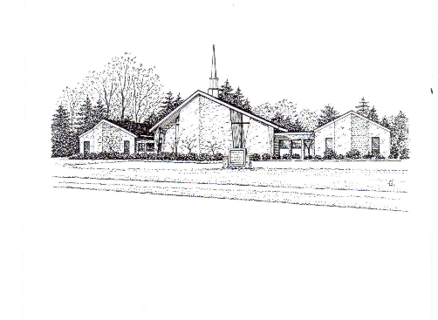

***St. Thomas Lutheran Positioning Statement:***

*St Thomas Lutheran Church is an inviting and caring environment*

*Nurtured by God’s Love where individuals and families*

*Grow in faith to meet the challenges of life.*

***St Thomas Mission:***

*Our Mission is*

*To celebrate God’s love through serving*

*Embrace it in our own lives*

*Reach out to our neighbors*

*And actively pass it on to new generations.*

