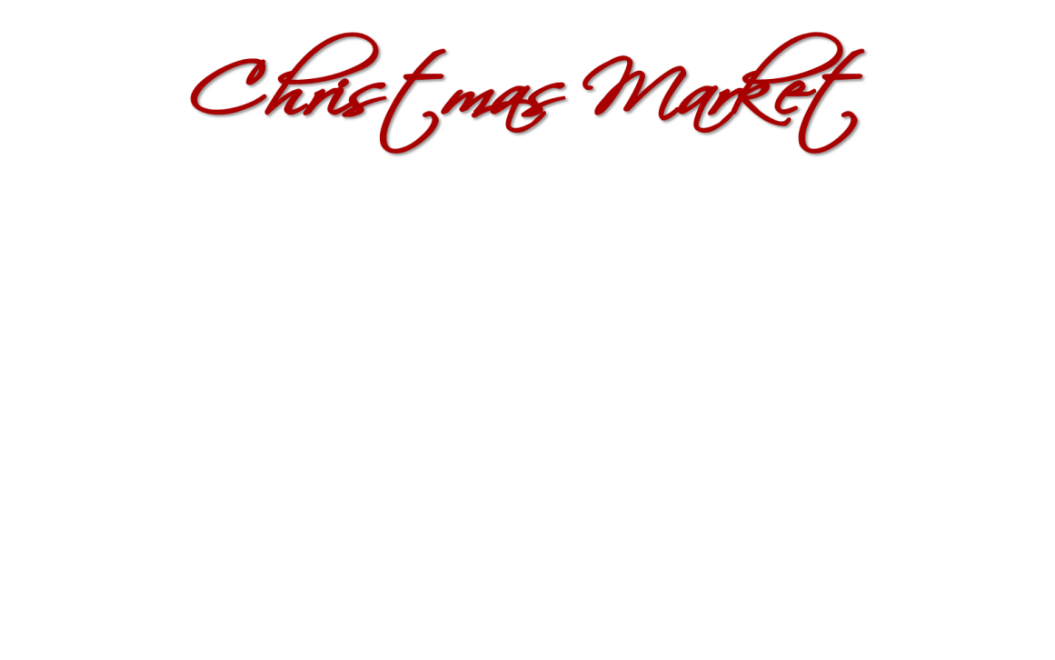



**Registration for the third annual**

**Christmas Market at St. Thomas! …Dec 2nd.**

I need space for ____6 ft. tables ____ 8 ft. tables … maximum 2 tables

Contact Linda Landis for table rental

Are you setting up on Friday (4-8pm) _________ (yes or no)

Please enclose a $20 registration fee (will go to our Good Samaritan Fund for needy individuals or families

Make Checks payable to:

St. Thomas Lutheran Church (notation Christmas Market Fee)

9393 Church, Grosse Ile 48138

Mail registration and check or drop off in the mailbox by the office door

Questions? … Linda Landis 734-552-2937 or Betty Ruck 734-558-4359

**Business Name**: ___________________________________________________________________

(please make one up if you don’t have one: ex. Betty’s Candles)

**Address:** __________________________________________________________________________

__________________________________________________________________________________

**Your Name** ________________________________________________________________________

**Phone** # :__________________________________________________________________________

**Email:** ____________________________________________________________________________

**Product:** ________________________________________________________________

I hereby agree to sell or offer for sale at the St. Thomas Lutheran Church Christmas Market only such items as listed above and that are my own production. Further, I acknowledge full responsibility for all activities conducted during the Christmas Market and agree to hold St. Thomas Lutheran Church harmless and to indemnify it from any and all claims arising under this permit.

Vendor’s signature ______________________________________________________________

Registration will be limited to the first 60 paid applicants

I hereby agree to sell or offer for sale at the St. Thomas Lutheran Church Christmas Market only such items as listed above and that are my own production. Further, I acknowledge full responsibility for all activities conducted during the Christmas Market and agree to hold St. Thomas Lutheran Church harmless and to indemnify it from any and all claims arising under this permit.

Vendor’s signature ___________________________________________________________