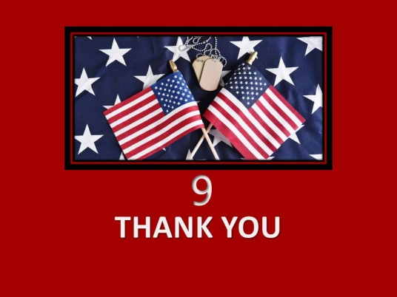

¹³ No one has greater love than this, to lay down one’s life for one’s friends. John 15:13

Is It Okay to Say ‘Thank You for Your Service’ to a Veteran?

The answer gets a 50/50 response. On the one hand, the answer is yes. And on the other hand, the answer is no. And both sides come with some caveats. For those in the yes category, the reasoning is straightforward. When you say thank you for anything in life, your intent is to express gratitude without pretense. For those in the no category, they caution against this phrase unless you’re aware of how that specific veteran’s feelings about their service, and traumas. How would you know what to say?

Three recommendations to solve the dilemma

- Acknowledge Veterans for their service by saying a simple: “Thank you for your service.” Whether that’s on Facebook, a text message, a phone call, a letter, or an in-person greeting, a basic acknowledgment can go a long way.
- Get involved in your community where veterans frequent: i.e., VFW, local Vet Center, American Legion, or local non-for-profit. Veteran organizations are always looking for volunteers. Ask them what they need the most and see if you are able to meet that demand.
- Start a conversation with the veteran about where they served and possibly relate to them based on their knowledge and experience. Simply taking an interest will go a long way.
PRAYER

Help us, dear God, to see your face in every Veteran we encounter. Guide us as we imagine new ways to support Veterans and their families. Bring healing and peace to all who have been wounded physically, mentally and spiritually during wartime. Help us bring your saving grace to heal the invisible wounds of war. We ask this in Jesus’ holy name. Amen.

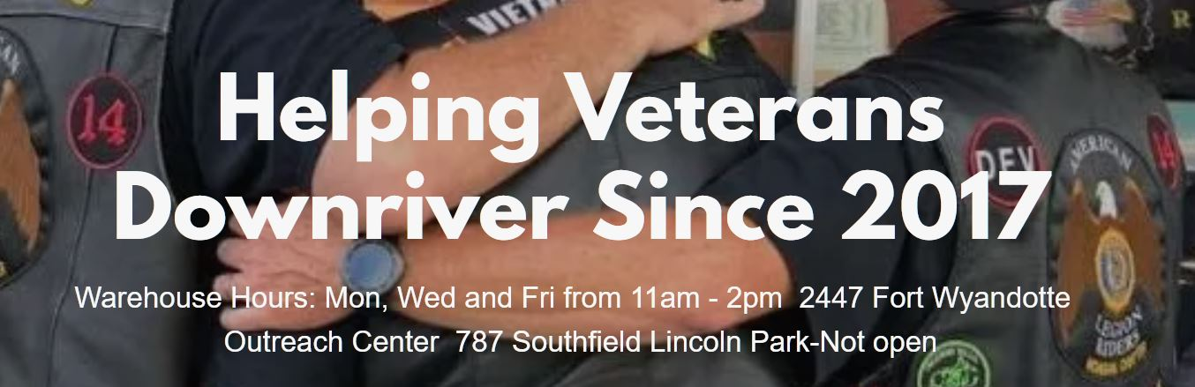Downriver for Veterans

is a 501(c)(3) dedicated to supporting local veterans in Downriver communities. We are dedicated to enhancing the pride and patriotism in all Michiganders by building a stronger, more supportive community around those who served us. We can serve veterans with emergency funds to assist with items such as rent, utilities, car repairs and other essential life expenses. In addition, we provide food, household goods and other life-essentials in times of need or due to unforeseen circumstances.

Address: 2447 Fort St (PO Box 275) Wyandotte 48192

Hours- Mon., Wed., Fri. 11am-2pm

Goods Donations:
- Non-perishable food items
- Pet food and litter
- Toiletries
- New Bedding
- Cannot accept medical supplies or clothing

Monetary Donations: https://downriverforveterans.org/other-donations

PROJECT: Building Tiny Homes Downriver for Vets

If you would like to contribute, follow this link and click on the donate button on the home page https://downriverforveterans.org Covid 19 has delayed finding land for this project but we are still hard at work trying to bring this dream to reality.

