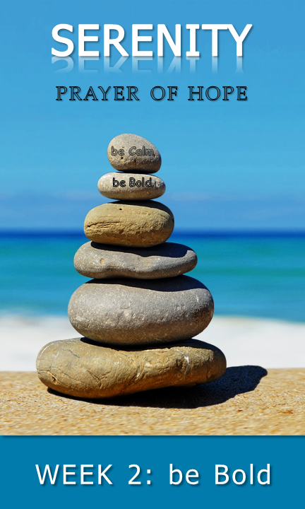
Pray

◻
♦
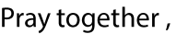
♦
1:7 (ESV)
THIS WEEK’S MEMORY VERSE
“…for God gave us a spirit not of fear but of power and love
and self control.” 2 Timothy 1:7 (ESV)
daily Bible verses
40 Days commitments

_______________________________________________________________

With permission and in partnership, St. Thomas Lutheran Church has adapted this study guide from Calvary Evangelical Lutheran Church’s (Clarkston, MI) series: 40 days of Courageous Prayer. It was inspired by Trevor Hudson’s book , The Serenity Prayer; A simple Prayer to Enrich Your Life, Rick Warren’s 40DAYS campaigns, and Rich Milheim’s FAITHS

share | part 1
be Bold | courage to change the things I can; and wisdom to know the difference

share | part 2

◻
=

♦
read | part 2

read | part 1

♦

talk | part 2

=
=
talk | part 1
=
=

Why is it often so difficult to examine our failings and flaws?
=
When have you “put pride in your pocket” and allowed God to change you?
=
What were the by-products of this courageous action?
=

