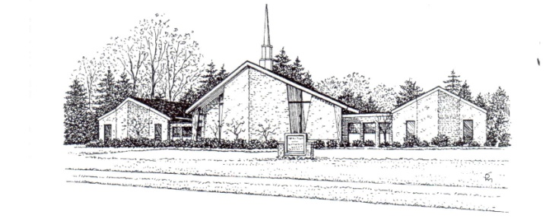
Rev. Heather K. Oberlin ST. THOMAS LUTHERAN CHURCH
9393 Church Road
Grosse Ile, MI 48138
Office: (734) 675-0005
Pastor Heather: (734) 675-8807
Fax: (734)675-5068
Emails: office@stthomasgi.com; pastor@stthomasgi.com Website: www.stthomasgi.com

MAY/JUNE 2018

A NOTE FROM PASTOR HEATHER

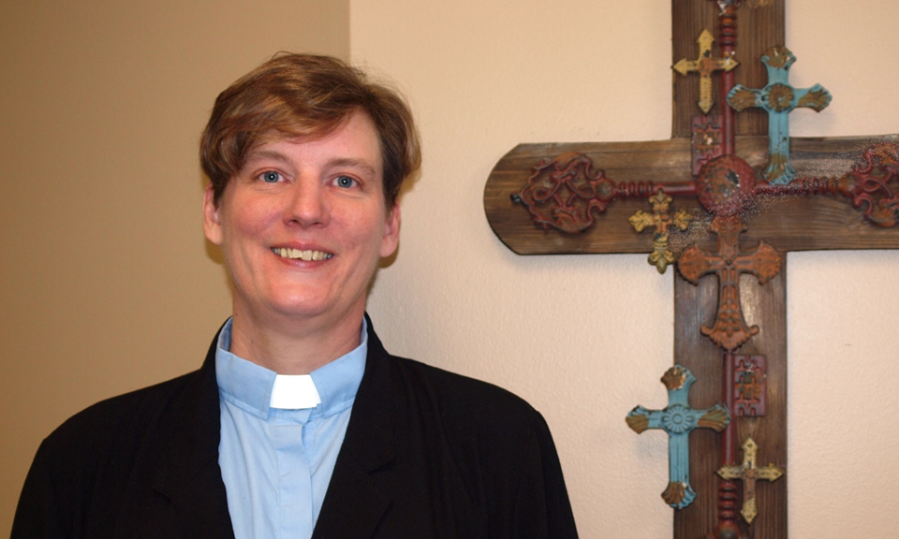
First, I want to thank all of you for the warm welcome you’ve shown the kids and me!! We are all so delighted to meet everyone and dive deep into the community. The kids are especially excited to meet other kids because, apparently, I’ve reached the status of “Boring Mom.” 😊
As we begin our ministry together, I want to share with you what a “typical” week will look like as we get further into May. Mondays and Wednesdays, I’ll be out and about in the community, meeting with community leaders and congregation members. Tuesdays and Thursdays, my office hours will be 10am-1pm, (so feel free to pop in and say hi!), and then, I’ll be back out in the community in the afternoons. And, of course, Thursday nights and Sunday mornings, I’ll be leading worship. My day off will be Fridays. Please know that if you want to get together but can’t stop by during office hours, you can always call me to set up an appointment!
I want to share with you what I shared with council members this week regarding my vision and goals.

Vision:
- A place where everyone is invited and trained to use their gifts, no matter how young or how old.
- A place where people can ask the tough questions without judgment.
- A place where leaders tithe and regularly attend Bible study and worship.

Goals:
- Meet with every member as soon as possible.
- Make Confirmation Sunday awesome!
- Find out what I don’t know.
- Meet with community/school leaders.
- Put sermons online…stream if possible.
- Send out “Monday reflections” on text for upcoming week to every member, and make them available online. Publicize everywhere.
- Invite people to Tweet/Instagram quotes that catch their attention from sermons/worship.
- Figure out how to use our tech to its fullest potential.
- Summer Bible study…lunch and learn? Dinner and digest?
- Work with Darcie for confirmation class and all ages.
- Camp next summer! (elementary thru high school)
- Begin working on a strategic plan/vision.

What else would you add to our goals? Let’s grab coffee and dream together!!

Blessed to be serving with you,
Pastor Heather

Connect with Pastor Heather!
Cell: 734-624-3273; Email: pastor@stthomsgi.com;
Facebook: Heather K. Oberlin

Pastor Heather leads her first Sunday worship as our new minister of St. Thomas on Sunday, May 13. Please save August 26 on your calendars for her formal installation service and reception.

NOTE FROM COUNCIL PRESIDENT

Rev. Heather K. Oberlin, will be the next spiritual leader for our church! Her experience, knowledge and pastoral abilities make her a great fit for our church and I am excited for the path that we have walked and will continue to march down in the future. There is another article specifically about Pastor Heather from the Call Committee, but I wanted to take the opportunity to thank several people who have supported our church over the past 10 months as we have gone through this transition.
Let me begin by thanking my fellow members on St. Thomas Council. Dr. Brian Long, Tammy Davis, Alicia and Rick Strong, Bill Stevenson, Kent and Karen Kujala and Betty Ruck, Lauren Graver and Matt Graver have all given of their time and energies to ensure the church had what it needed to seamlessly continue church operations and support the staff, Pastor Bill and the Call Committee during this interim period.
This leads to our St. Thomas Staff. There is no better group of people who support the missions and goals our church. It is especially difficult to keep the ship afloat when we are in a period of uncertainty like we have been since last summer. Your extraordinary efforts delivered continued support for our church, our youth and the rest of our congregation. Thank you, Linda Landis, Darcie Bammer, Carol Cameron, Shelley Creutz, Bob Krzeczkowski, and Karen Skrocki. Your commitments are greatly appreciated!
I would also like to thank Pastor Branden Hunt, for conducting our confirmation classes this year with our St. Thomas middle School students and continuing to be a spiritual connection for the High School youth of our church.
The Call Committee performed their duties with great conviction and are worthy of the trust you put in them to understand our mission and use it as a guide to discover our next Pastor. I truly appreciated the open discussions, honest reflection and spiritual journey experienced by each of you in your own unique ways during this process.



I would like to thank the members of the committee, Sandi Loso, Al Skrocki, Andrea Stevenson, David Patterson, Hailey Swamy, Jeff Kline, and Erin Shelton.
I would like to thank Pastor Bill Kirsch-Carr and his family for his time with our congregation. During this time Pastor Bill served as a supportive counselor, a spiritual leader, and an agent of change for our church. He introduced us to some different Lutheran traditions and subtlety, or maybe not so, made us a little more open to accepting new ways of worship and expressing our faith. Although his time with us was short, I will look back at it with fond memories and with a sense of growth in my own spiritual journey.
Finally, I would like to thank all the members of St. Thomas Lutheran. Your dedication to your faith and patience during this call process has been truly humbling. These times of transition can feel uncomfortable or uncertain at times but seeing the people of our congregation continuing to be involved and remaining steadfast helped to move forward with confidence and determination. I was amazed at the overwhelming support of Pastor Heather. The trust this demonstrates is incredibly satisfying.
I am excited to see where our church will go from here. I suspect many things will stay the same, but with new leadership comes new opportunities and I eagerly anticipate great things on the horizon.

Thank you,
Keith Lakatosh
St. Thomas Council President

Council Members: Tammy Davis, Matthew Graver (Youth Rep.), Brian Long, Karen Kujala, Kent Kujala (Treasurer), Betty Ruck , Bill Stevenson, Alicia Strong, Rick Strong
council@stthomasgi.com
YOUTH NIGHT

May 13 – No Youth Night so kids can be with their moms.

We are planning on doing the Mulch Friday May 18th from 5 to 7 pm- This will be our rain date and hopefully it will work for everyone. Pitch forks and wheel barrows will also be needed. All are welcome to help!


CONFIRMATION IS PLANNED FOR SUNDAY, MAY 20 AT 10:00AM. A reception will be held following the service. Confirmands, please send to the church about 4-5 pictures for a video presentation by May 14.

May 20 – Last youth night for all ages until the fall.

We will be planning an end of the year gathering- details to follow!

Thank you to all who volunteer - we couldn’t do it without you!

THANK YOU FOR ALL WHO DONATED TO THE YOUTH “J (Jesus) & C (Christ) Dollar” Day - YOUTH COLLECTION. In total $533.36 was raised for a women’s shelter to buy hygiene products!

FOUR YOUTH FROM ST. THOMAS ARE GOING TO THE NATIONAL YOUTH GATERHING IN HOUSTON JUNE 27 – JULY 1 – Ryan Brozek , Josh & Joe Davis, and Kyle Strong. Please offer your prayers and support. Total cost of the trip is $6,500 and so far $5,200 has been raised.

SUNDAY SCHOOL



Sunday School continues at 10:00am on Sunday mornings through June 17.

2018 VBS


MARK YOU CALENDARS FOR THE WEEK OF AUGUST 6-10 FOR VBS
Details and sign up coming soon!

ST. THOMAS WILL RECOGNIZE ITS 2018 HIGH SCHOOL GRADUATES

Congratulations to all of the 2018 Graduating Class!

ON SUNDAY, JUNE 3, we will recognize those graduating this year. High School Seniors, please send to the church about 4-5 pictures for a video presentation BY MAY 28. The pictures may be emailed or brought to the office for scanning.

The Rev. Edward R. Aller Scholarship, sponsored by the St. Thomas WELCA, will also be awarded at this service. Scholarship criteria is based on volunteering on a free basis for our church and other organizations, regular church attendance and community service (scouts, etc.) and school projects.

HAPPY MOTHER’S DAY – MAY 13


HAPPY FATHER’S DAY – JUNE 17


Please remember FATHER’S DAY IS JUNE 17. We will have a video slide tribute to Dad, so if you would like to submit a picture or two of your father please submit them to the office electronically or in person. Please submit by June 11.
BAPTISMS


On Sunday, April 15, 2018
Faith Christine Ballantyne And
Grace Elizabeth Ballantyne
were welcomed into the family
of St. Thomas by Baptism
Parents are Ryan and Denise Ballantyne
Godparents are Matthew Kovach
and Renee Sabon

ST. THOMAS T-SHIRTS



A SIGN UP IS ON THE BULLETIN BOARD IF YOU ARE INTERESTED IN ORDERING A ST. THOMAS T-SHIRT. All sizes available.

KITCHEN SHOWER/PROPERTY



Please take an umbrella from the tree in the narthex and return item to church. All donations greatly appreciated!! Opportunities will be coming up soon to help around the church.

Watch for a task board to volunteer for small jobs needed around the building and yard.

THANK YOU FOR EASTER FLOWERS

Thank you to the following that provided flowers for our altar on Easter Sunday

Gayle Mitchell
In memory of Carl & Dolly Geloneck and Donna Black

Judith Danziger
In memory of John Danziger and
Bill Greig, Sr.

Jeff & Sherel Karrar In memory of John & Martha Slocum and Marjorie Karrar

Agnes Kujala in memory of Doug Kujala

Ethel J. Yops
In memory of Robert C. Yops Sr.
and Robert C. Yops Jr.

Joan DeByle in memory of Ken DeByle
and Betty Hoeft

The Arndt Family
In memory of Rev. Steve Dewey,
Cliff & Ernestine Gronda
and Robert & Margaret Arndt

Richard and Gayle Withey
In memory of Ray & Mildred Withey
and Ruth & Clyde Lattimore

Andrea & Bill Stevenson in memory
of Marian Skrycki

SYMPATHIES

Sympathies of the congregation are extended
To Maggie Gibson and her family as her
Mother, Estelle Semetko, age 99 years and10 months,
passed away. A service was held on May 10.


Prayers and sympathies of the congregation are extended to the
family of Carol Rice who passed away April 13.
A memorial service was held on April 29, in Livonia.
GRACE IN ACTION

THANK YOU TO ALL WHO ATTENDED THE GRACE IN ACTION service and luncheon last Sunday, May 6. $1,287 was raised to help this ELCA mission church in southwest Detroit! Thank you to Al & Karen Skrocki and Linda Landis for their planning and organization. Thank you also to Pastor John Cummings of Grace In Action for updating us on their mission and leading us in worship. (GRACE IN ACTION is an ELCA mission church in southwest Detroit that is reaching out to engage its community in worship and social empowerment activities.)

MAY BIRTHDAYS



Steven Landis 5/2
Abigail Long 5/2
Maxwell Mataverde 5/2
Lisa Perry 5/2
Paula Riley 5/2
Katherine Benko 5/5
Natalie Wallace 5/6
Lucas Osburn 5/8
Matthew Perry 5/9
Sharon Warner 5/10
Fred Parrill 5/11
Caleb Nelson 5/12
Kathie Kline 5/13
Ryan Brozek 5/14
Matt Shelton 5/15
Russ Cameron 5/16
Emma Blackburn 5/17
Olivia Corney 5/17
Lennox Dauter 5/18
Annette Burk 5/22
George Ruck III 5/22
Addison Lesperance 5/24
Chloe Pfeiffer 5/25
Michael Bacha 5/25
Robert Kujala 5/26
Natalie Mataverde 5/29
Grace Ballantyne 5/31
JUNE BIRTHDAYS



Erika Kwan 6/02
Cole Gladowski 6/04
Ryan Haworth 6/04
Katelyn Graver 6/07
Bill Medick 6/08
Jonathan Kline 6/11
Denise Tillman 6/12
Cliff Gibson 6/13
Cecilia Cameron 6/13
Denise Keeler 6/15
Lisa Haworth 6/17
Alex Karrar 6/18
Hailey Swamy 6/19
Krista Ewbank 6/20
Ava Kelso 6/21
Brian Long 6/21
Ellise Flessland 6/24
Madeline Mataverde 6/24
Gayle Withey 6/24
Kaye Hoffmeyer 6/26
Jordan Hudec 6/26
Patrick Kline 6/29

WORSHIP SCHEDULE

Thursday (casual) Worship @ 7:00pm

Sunday Worship 10:00am

Sunday School 10:00am through June 17

Quilters: Mondays @ 9:00am



MAY 2018

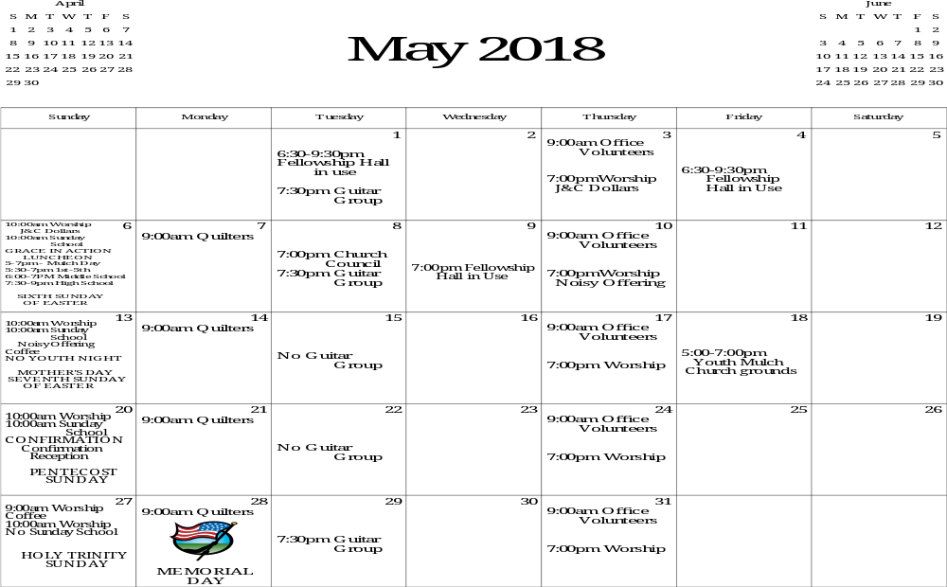

MAY SERVANTS OF ST. THOMAS
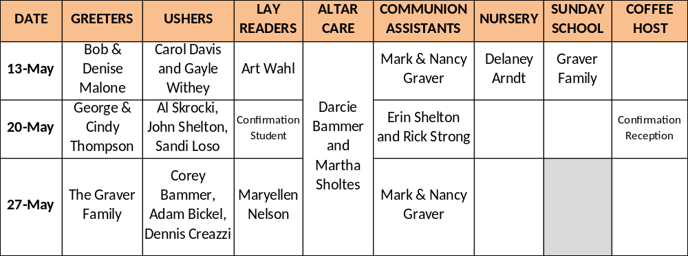
JUNE 2018
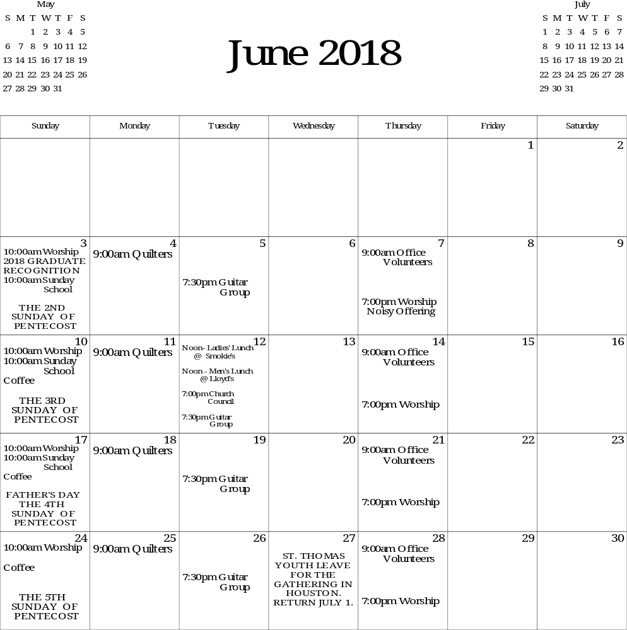



JUNE SERVANTS OF ST. THOMAS
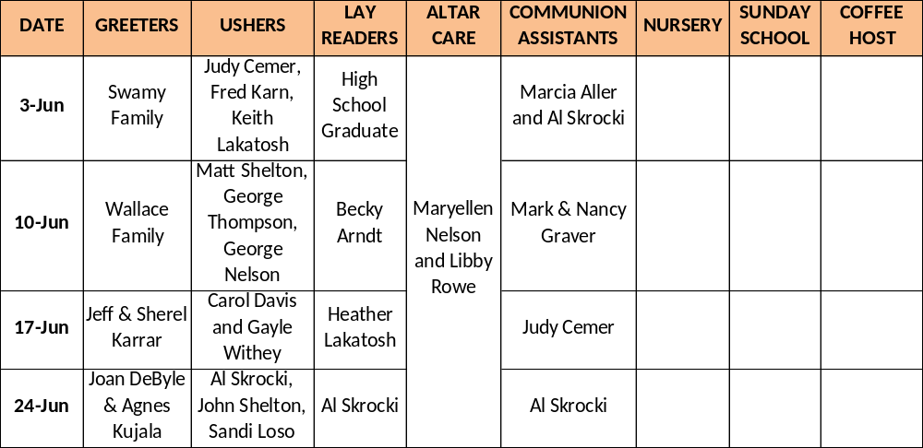

PLEASE PRAYERFULLY CONSIDER YOUR PARTICIPATION IN ONE OF THESE AREAS FOR THE SUNDAY SERVICES: NURSERY, GREETERS, USHERS, COMMUNION SET UP, LAY READERS, COFFEE HOSTS AND COMMUNION ASSISTANTS. PLEASE INDICATE ON YOUR CONNECTION CARD WILLINGNESS TO HELP AS GREETERS, USHERS, COMMUNION SETUP AND ASSISTANTS & LAY READERS.

DONATIONS TO SACRED HEART'S FOOD PANTRY CONTINUE


Thank you to all who have been bringing in needed items. The third week of each month the donations are taken over to the Food Pantry at Sacred Heart. Collected are non-perishable goods such as Progresso Soups and Campbell Chunky Meals (used by the older population to add to their Meals on Wheels food). In addition to other canned foods, children's snacks such as small containers of applesauce, fruit, juice boxes, small bags of cookies, peanut butter & jelly are appreciated. Paper products and cleaning supplies are items that are greatly needed that cannot be purchased with the Bridge card assistance program. Thank you to Sandi Loso who packs and transports the items to Sacred Heart each month.

OTHER ITEMS OF INTEREST

- THE MEN’S LUNCH GROUP meets at Lloyds on the 2nd Tuesday of each month.
- A LADIES LUNCH GROUP also meets the 2nd Tuesday of each month at Smokies on the Water at noon.
- QUILTING GROUP - This dedicated group continues to meet on Monday mornings at 9:00am. The group welcomes anyone who can tie a knot! Some weeks they assemble as many as 8 quilts! Donations of sheets are always welcome!
- Island HerbFest Saturday, May 19 – 9am-2pm at Centennial Farm. More information on Facebook: Grosse Ile Herb
- JUNE 2-4–ISLANDFEST–PARADE JUNE 3 @ 10AM
- DEVOTIONAL BOOKLETS are available in the tract rack in the Narthex for you to take.

