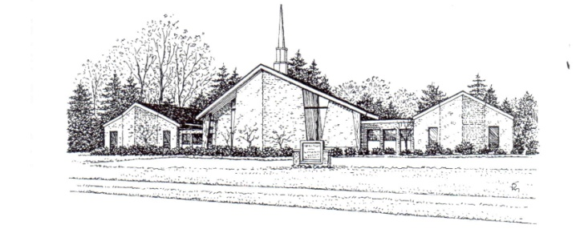
Sean Ewbank, Pastor ST. THOMAS LUTHERAN CHURCH
9393 Church Road
Grosse Ile, MI 48138
(734) 675-0005; (734) 675-8807
Fax: (734)675-5068
Pastor Sean: (734) 250-1655
Emails: pastorsean@stthomasgi.com office@stthomasgi.com Website: www.stthomasgi.com

MAY/JUNE 2017

Greetings! Christ is Risen!

May and June are wonderfully filled with opportunities to celebrate and serve with all the people of St Thomas! Please carefully read this newsletter and make note of the events you would like to participate in.
Sunday, May 7, has two great events. First, during worship that weekend we will celebrate with those graduating from High School. Let’s help celebrate their accomplishments together with joy. Immediately following our worship service we will have a spring cleaning day at St Thomas. Come and take pride in your church building, furnishings, and grounds. We will have tasks outside which will require some willingness to sweat and get dirty along with some tasks that can be accomplished inside sitting at a table in the air conditioning. Do please plan on helping out and enjoying an afternoon of conversation and feeling good about accomplishing tasks together with others who make up the St Thomas family.
Sunday May, 14, is Mother’s Day. If you have not yet submitted a photo of mom, please do so by May 1! Come that day and see the pictures of all those who we lift up with thanksgiving and celebrate together.
June 4 is Confirmation Sunday. Come and see our 8th grade students affirm their baptism and celebrate with them.
June 11 is the pool party at my house, assuming the weather co-operates. Come and have fun!
June 18 is Father’s Day. Again, please submit pictures as soon as you can so that we are able to celebrate dads that day. Also, this Sunday marks the beginning of our summer schedule when we move to only one service on Sunday mornings. That one service will be at 10am. The Thursday 7pm services will continue.
Have a wonderful rest of your spring and do come and share the Spirit!
Peace, Hope, Love, and Joy,
Pastor Sean

WORSHIP SCHEDULE

Thursday Worship @ 7:00pm
will continue through the summer

Sunday Worship @ 9:00am and 10:30am
through June 11

Sunday Worship will be at 10:00am only
beginning June 18


ST. THOMAS SPRING CLEAN UP SUNDAY, MAY 7

May 7th is the annual spreading of the mulch throughout the yard of St. Thomas. This year we have expanded the Spring Clean Up Event to the entire congregation and we will have tasks which need completion from after the last service until dusk. Please consider even an hour or two if you can. All help greatly appreciated. A sign up is on the bulletin board along with a list of tasks and supplies needed.




ST. THOMAS WILL RECOGNIZE ITS 2017 HIGH SCHOOL GRADUATES

Congratulations to all of the 2017 Graduating Class!

ON SUNDAY, MAY 7 we will recognize those graduating high school this year. Seniors, please send to the church about 4-5 pictures for a video presentation BY MAY 1 please. The pictures may be emailed or brought to the office for scanning. The Rev. Edward R. Aller Scholarship, sponsored by the St. Thomas WELCA, will also be awarded at this service.

The St. Thomas seniors this year are Kate Bickel, Justine Brozek, Devin Cemer, Maddy Davis, Logan Gladowski, Katie Graver, Danielle Thompson and Halena Torosian.

A Baccalaureate was held on Sunday, June 4 at Sacred Heart Catholic Church at 5:00pm. Grosse Ile High School graduation is June 8.

YOUTH NIGHT



A great time was had by all that attended the Youth event at Great Wolf Lodge in Traverse City in March and the church middle school lock-in on April 21. Thank you to the chaperones that helped out- Pastor Sean, Mark & Linda Hinzmann and Lori Bartos!

May 7 – Regular Youth Night for 1st grade through high school. Youth will be helping spread mulch around the church grounds. Also, Parent Meeting for Confirmation with all the middle school parents from 5:30-7:00pm.

May 14 – No Youth Night so kids can be with their moms.


May 21 – Last youth night for all ages until the fall.

CONFIRMATION/PENTECOST
SUNDAY – JUNE 4 @10:30AM

June 11 – Annual Pool Party at the Ewbank’s house – weather permitting.

Confirmation Camp is July 9-14
SUNDAY SCHOOL

Sunday School continues at 10:30am on Sunday mornings through June 11.

MARK YOU CALENDARS FOR
THE WEEK OF AUGUST 14-18 FOR VBS
Details and sign up coming soon!

ART AND SOUL

St Thomas is privileged to host an art exhibit on Sunday, May 28th. Come and check out the beautiful portraits that capture personalities, hope of children seeking homes that will be on display. You will also have an opportunity to learn about foster care and adoption as that is the theme of the exhibit.

QUILTING GROUP

This dedicated group continues to meet on Monday mornings at 9:00am. The group welcomes anyone who can tie a knot! Some weeks they assemble as many as 8 quilts!

MOTHER’S DAY

Happy Mother’s Day to all moms on May 14! If you would like to submit a picture or two of your mother to be included in a special video slide tribute to be shown in church on Mother’s Day, please submit them to the office electronically or in person.

Pictures must be submitted by May 8.

Happy Father’s Day – June 19


While looking for pictures of Mom – please remember FATHER’S DAY IS JUNE 18. We will also have a video slide tribute to Dad, so if you would like to submit a picture or two of your father please submit them to the office electronically or in person. Please submit by June 12.
BAPTISMS


On Sunday, March 12, 2017
Carter Ashton Lesperance was welcomed
into the family of St. Thomas by Baptism
Parents are Kyle & Ashlee Lesperance
Godparents are Carolyn & Joshua Lesperance

On Sunday, March 19, 2017
Kennedy Lynn Crawford was welcomed
Into the family of St. Thomas by Baptism
Parents are Steven & Andrea Crawford
Godparents are Sarah & Ryan Stachler and
Amy & James Klontzans

On Sunday, April 30, 2017
We will welcome Colin Robert Geftos
Parents are Nick & Lynn Geftos
Godparents are Sean DeFrates and Stacey Berman

ST. THOMAS MUTUAL MINISTRY TEAM

Did you know. . . What the Mutual Ministry Team does?
The St Thomas Mutual Ministry Team has three main functions. . .
1. Support the pastor mainly by listening and giving feedback. The pastor might want to bounce possible future ministry ideas off the team to get feedback. The pastor may wish to share joys or struggles from his/her personal life with a safe group of listeners.
2. Act as the personnel team for the congregation. Work on job descriptions, interview candidates, and give performance reviews.
3. Be a listening ear in the congregation and facilitate communication for those experiencing difficulties who are having trouble expressing their feelings appropriately.

So, if you ever have any questions, comments, or suggestions that you don’t know who to take them to, take them to one of us. We are.
Richard Withey, Sandi Loso, Al Skrocki, and Becky Arndt.

A NOTE FROM ST. THOMAS’
CHURCH COUNCIL

Blessed Children of St. Thomas,

The Spring season is upon us and with that a renewed sense of the majesty of new life, growth, and the beauty of God’s world. We would like to begin by thanking you for blessing St. Thomas with your membership and helping us “Reach Out With God’s Love.” The success of our mission relies heavily on the support of our congregation spiritually, physically, and financially. It is our hope that our worship services strengthen your faith in God, enhances your understanding of God’s Grace, and renews your commitment to living out God’s word through acceptance of Jesus Christ, our savior.

The Church Council is hard at work shifting our strategy to best align with the priorities of the church as defined by the teachings of Jesus. As we do this, we will continue to share our hopes and plans with the Congregation and how we can utilize the time, talents, and resources of our members towards our shared ambitions. We also commit to full transparency regarding our financial position and concerns.

It is with this transparency that we share the current budgetary position so far this year. Below is a simple chart of our Income and expense for the first part of the year.
 | Budget | Actual (Jan – Mar) | YTD Over (Under)
Income | $ 69,200 | $ 61,787 | ( $ 7,413 )
Expense | $ 68,584 | $ 66,202 | ( $ 2,382 )
Net Cash Flow |  |  | ( $ 5,031 )
As you can see, our year to date giving is below our forecast, set by our approved budget presented this past December. This has put a strain on our annual budget and our cash reserves. We understand that our members have given generously and for that we are humbled and blessed and we will continue to look for opportunities to improve our cash position. As a Council, we are exploring ways to continue to reduce our spending and utilize the time, talent, resources of our members through volunteer activities within our house of worship to circumvent otherwise costly expenses. We look forward to Reaching out to you and other members of our wonderful family at St. Thomas as we continue to strive for the fulfillment of our mission.

Have a blessed Day!
The St. Thomas Church Council

WEDDING


Congratulations to
Kate Warner and
Beau Beidelschies
who were united in marriage
on March 31st

THANK YOU FOR EASTER FLOWERS

Thank you to the following that provided flowers for our altar on Easter Sunday

Ethel J. Yops
In memory of Robert C. Yops Sr.
and Robert C. Yops Jr.

Gayle Mitchell (2)
In memory of Carl & Dolly Geloneck
and Donna Black

Pete & Sandi Loso (2)
In memory of Dick & Val Carr
and Pete & Elizabeth Loso

Joan DeByle in memory of Ken DeByle

Pastor Ewbank Family & Tamara Howes (17)
In memory of Norman, DeEtte and Greg Ewbank

Richard and Gayle Withey (2)
In memory of Ray & Mildred Withey
and Ruth & Clyde Lattimore

Jeff & Sherel Karrar (2)
In memory of John & Martha Slocum
and Marjorie Karrar

Judith Danziger
In memory of John Danziger

SYMPATHIES
Sympathies of the congregation are extended
to Kathie & Jeff Kline and their family
on the passing of Ann Wesley on February 9.
Ann was a long time and faithful member of
St. Thomas and she will be greatly missed.


MAY BIRTHDAYS
Steven Landis 5/2
Abigail Long 5/2
Maxwell Mataverde 5/2
Lisa Perry 5/2
Paula Riley 5/2
Katherine Benko 5/5
Natalie Wallace 5/6
Lucas Osburn 5/8
Matthew Perry 5/9
Sharon Warner 5/10
Fred Parrill 5/11
Caleb Nelson 5/12
Kathie Kline 5/13
Ryan Brozek 5/14
Matt Shelton 5/15
Russ Cameron 5/16
Emma Blackburn 5/17
Olivia Corney 5/17
Lennox Dauter 5/18
Annette Burk 5/22
George Ruck III 5/22
Addison Lesperance 5/24
Chloe Pfeiffer 5/25
Richard Papp 5/25
Michael Bacha 5/25
Robert Kujala 5/26
Natalie Mataverde 5/29

Grace Ballantyne 5/31

JUNE BIRTHDAYS
Erika Sanquist 6/02
Cole Gladowski 6/04
Ryan Haworth 6/04
Katelyn Graver 6/07
Bill Medick 6/08
Denise Tillman 6/12
Cliff Gibson 6/13
Denise Keeler 6/15
Lisa Haworth 6/17
Alex Karrar 6/18
Hailey Swamy 6/19
Krista Ewbank 6/20
Ava Kelso 6/21
Brian Long 6/21
Ellise Flessland 6/24
Madeline Mataverde 6/24
Gayle Withey 6/24
Kaye Hoffmeyer 6/26
Jordan Hudec 6/26

TO ALL THOSE WHO SUPPORTED
AL’S JOURNEY


On April 23 Al Skrocki gave a very interesting and wonderful presentation of his amazing journey on the Appalachian Trail.

After hiking over 600 miles and passing the ¼ way point in 7 weeks, Al came home with a severe knee injury. His return to the trail is undetermined at this time, but he said he would do it again in a heartbeat. He has inspired so many and what he has accomplished is awesome. Congratulations Al!


His journey was encouraged by supporters for which he is tremendously grateful. The $3,760 in proceeds was distributed equally to several of St. Thomas’ Missions: Grace in Action in Detroit, Beit Sahour in Israel, MBULU Synod in Tanzania and to the St. Thomas Youth Ministry.

Visit our website for more pictures from Al’s Journey.

MAY SERVANTS OF ST. THOMAS
DATE | SERVICE | GREETERS | USHERS | LAY READERS | ALTAR CARE | COMMUNION ASSISTANTS | NURSERY | SUNDAY SCHOOL
7-May | 9:00am | The Karrar Family | Elke Malcomson, Carol Davis, Gayle Withey | Sal Finazzo | Martha Sholtes, Darcie Bammer | Corey & Darcie Bammer
7-May | 10:30am | The Karrar Family | Elke Malcomson, Carol Davis, Gayle Withey | Katie Graver | Martha Sholtes, Darcie Bammer | Sandi Loso & Erin Shelton | Cara Creutz
14-May | 9:00am | Ethel Yops & Elke Malcomson | Al Skrocki, Sandi Loso, John Shelton | Corey Bammer | Martha Sholtes, Darcie Bammer | Mark & Nancy Graver
14-May | 10:30am | Ethel Yops & Elke Malcomson | Al Skrocki, Sandi Loso, John Shelton | George Thompson | Martha Sholtes, Darcie Bammer | Richard & Gayle Withey | Danielle Thompson & Abigail Long
21-May | 9:00am | Bob & Denise Malone | Corey Bammer, Adam Bickel, Denis Creazzi | Maryellen Nelson | Martha Sholtes, Darcie Bammer | Mark & Nancy Graver
21-May | 10:30am | Bob & Denise Malone | Corey Bammer, Adam Bickel, Denis Creazzi | Heather Lakatosh | Martha Sholtes, Darcie Bammer | Rick Strong & Dan Sanquist | Cara Creutz & Danielle Thompson
28-May | 9:00am | The Graver Family | Judy Cemer, Fred Karn, Keith Lakatosh | Pastor Sean | Martha Sholtes, Darcie Bammer | Corey & Darcie Bammer
28-May | 10:30am |  |  |  |  | Stuart & Denise Keeler | Danielle Thompson
JUNE SERVANTS OF ST. THOMAS
DATE | SERVICE | GREETERS | USHERS | LAY READERS | ALTAR CARE | COMMUNION ASSISTANTS | NURSERY | SUNDAY SCHOOL
4-Jun | 9:00am | The Wallace Family | Matt Shelton, George Thompson, George Nelson | Pastor Sean | Maryellen Nelson, Libby Rowe | Mark & Nancy Graver
4-Jun | 10:30am |  |  |  |  | Richard & Gayle Withey | Cara Creutz
11-Jun | 9:00am | The Swamy Family | Elke Malcomson, Carol Davis, Gayle Withey | Art Wahl | Maryellen Nelson, Libby Rowe | Corey & Darcie Bammer
11-Jun | 10:30am | The Swamy Family | Elke Malcomson, Carol Davis, Gayle Withey | Win Kurlfink | Maryellen Nelson, Libby Rowe | Stuart & Denise Keeler | Danielle Thompson
18-Jun | 10:00am | Sonny & Debbie Ouellette | Al Skrocki, Sandi Loso, John Shelton | Marcia Aller | Maryellen Nelson, Libby Rowe | Sandi Loso & Dan Sanquist | Danielle Thompson
25-Jun | 10:00am | Pete & Sandi Loso | Corey Bammer, Adam Bickel, Denis Creazzi | Becky Arndt | Maryellen Nelson, Libby Rowe | Rick Strong & Erin Shelton
PLEASE PRAYERFULLY CONSIDER YOUR PARTICIPATION IN ONE OF THESE AREAS FOR THE SUNDAY SERVICES: GREETERS, USHERS, COMMUNION SET UP, LAY READERS, COFFEE HOSTS AND COMMUNION ASSISTANTS. PLEASE INDICATE ON YOUR CONNECTION CARD WILLINGNESS TO HELP AS GREETERS, USHERS, COMMUNION SETUP AND ASSISTANTS & LAY READERS.
Please volunteer to help out in the Nursery during the Sunday worship services.

DONATIONS TO SACRED HEART'S FOOD PANTRY CONTINUE
Thank you to all who have been bringing in needed items. The third week of each month the donations are taken over to the Food Pantry at Sacred Heart. Collected are non-perishable goods such as Progresso Soups and Campbell Chunky Meals (used by the older population to add to their Meals on Wheels food). In addition to other canned foods, children's snacks such as small containers of applesauce, fruit, juice boxes, small bags of cookies, peanut butter & jelly are appreciated. Paper products and cleaning supplies are items that are greatly needed that cannot be purchased with the Bridge card assistance program. Thank you to Sandi Loso who packs and transports the items to Sacred Heart each month.
KROGER COMMUNITY REWARDS

It was nice to learn that Kroger Plus Card members no longer have to re-register for community rewards each year. St. Thomas is very grateful to all who designate St. Thomas as the recipient of proceeds from the program. In March St. Thomas received a quarterly reward for $203! Thank you!
IF YOU ARE NEW TO ENROLL YOU MAY DO SO AT ANY TIME: You must have an e-mail and set up a password with Kroger. Go to www.krogercommunityrewards.com; Click "Enroll" then follow the prompts as directed. You will need your Kroger Plus Card number. St. Thomas’ NPO number is 84955. Detailed instructions are available in the church office. Please note it may take about 10 days after registering for the rewards to show up on your receipts.

If you do not have a computer but would like to register, please contact the office and we will help you. Again, St. Thomas appreciates your time and support!

MAY 2017
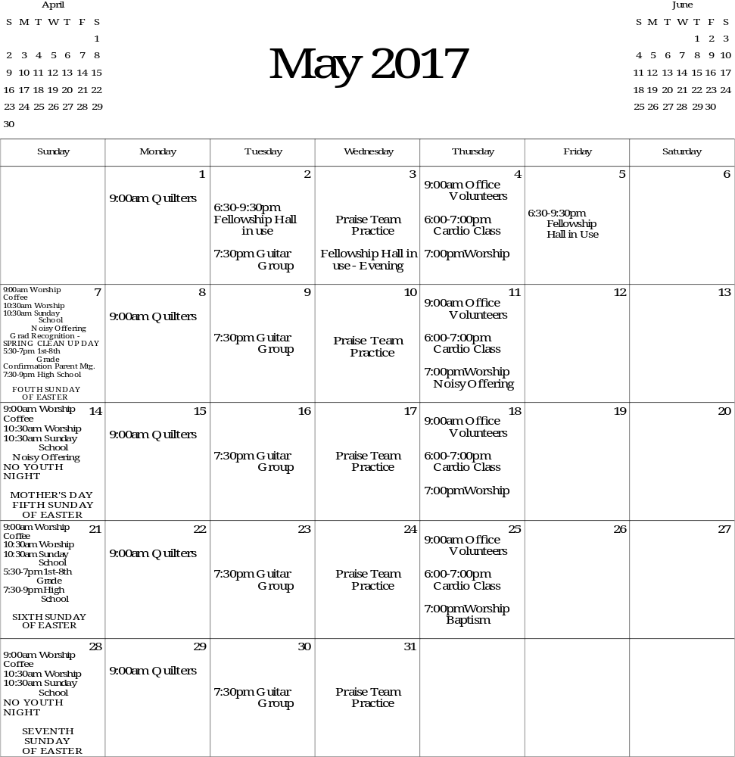
SYNOD ASSEMBLY
- DOWNRIVER NATIONAL DAY OF PRAYER IS THURSDAY, MAY 4.
- SEMISYNOD ASSEMBLY- THURSDAY, MAY 4 - SATURDAY, MAY 6, 201 at Blue Water Convention Center in Port Huron. This year's theme is "From Chaos to Community ~ Mark 8:1-10.”
- MEMORIAL DAY IS MAY 29.

JUNE 2017
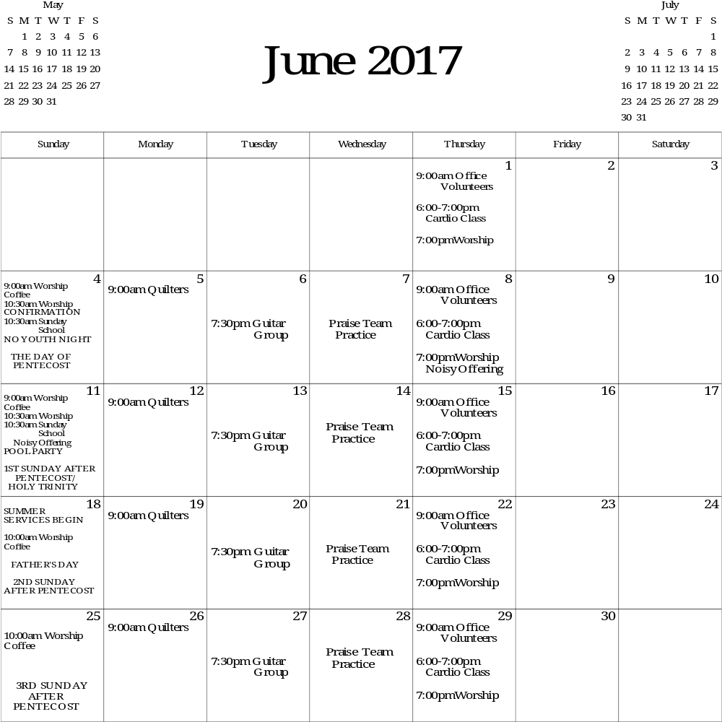
- JUNE 4 - CONFIRMATION
- JUNE 2-4–ISLANDFEST–PARADE JUNE 3 @ 10AM
- JUNE 11 – POOL PARTY AT THE EWBANK’S HOUSE
- DEVOTIONAL BOOKLETS are available in the tract rack in the Narthex for you to take.

