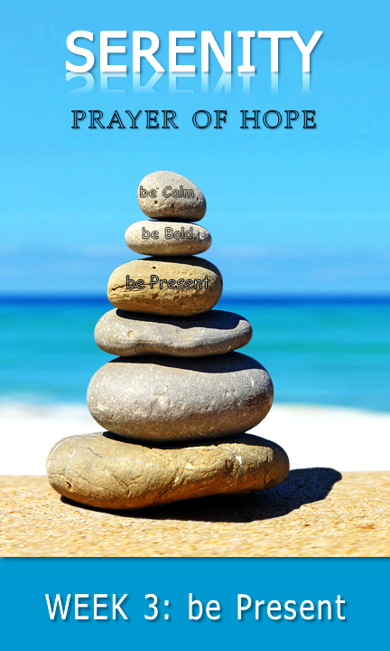
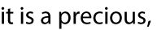
◻

♦
♦
♦

pray
♦
♦

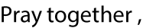
♦

With permission and in partnership, St. Thomas Lutheran Church has adapted this study guide from Calvary Evangelical Lutheran Church’s (Clarkston, MI) series: 40 days of Courageous Prayer. It was inspired by Trevor Hudson’s book , The Serenity Prayer; A simple Prayer to Enrich Your Life, Rick Warren’s 40DAYS campaigns, and Rich Milheim’s FAITHS

With permission and in partnership, St. Thomas Lutheran Church has adapted this study guide from Calvary Evangelical Lutheran Church’s (Clarkston, MI) series: 40 days of Courageous Prayer. It was inspired by Trevor Hudson’s book , The Serenity Prayer; A simple Prayer to Enrich Your Life, Rick Warren’s 40DAYS campaigns, and Rich Milheim’s FAITHS

daily Bible verses

With permission and in partnership, St. Thomas Lutheran Church has adapted this
study guide from Calvary Evangelical Lutheran Church’s (Clarkston, MI) series: 40 days of Courageous Prayer. It was inspired by Trevor Hudson’s book , The Serenity Prayer;
A simple Prayer to Enrich Your Life,Rick Warren’s 40DAYS campaigns,
and Rich Milheim’s FAITHS

With permission and in partnership, St. Thomas Lutheran Church has adapted this study guide from Calvary Evangelical Lutheran Church’s (Clarkston, MI) series: 40 days of Courageous Prayer. It was inspired by Trevor Hudson’s book , The Serenity Prayer; A simple Prayer to Enrich Your Life, Rick Warren’s 40DAYS campaigns, and Rich Milheim’s FAITHS

With permission and in partnership, St. Thomas Lutheran Church has adapted this study guide from Calvary Evangelical Lutheran Church’s (Clarkston, MI) series: 40 days of Courageous Prayer. It was inspired by Trevor Hudson’s book , The Serenity Prayer; A simple Prayer to Enrich Your Life, Rick Warren’s 40DAYS campaigns, and Rich Milheim’s FAITHS

With permission and in partnership, St. Thomas Lutheran Church has adapted this study guide from Calvary Evangelical Lutheran Church’s (Clarkston, MI) series: 40 days of Courageous Prayer. It was inspired by Trevor Hudson’s book , The Serenity Prayer; A simple Prayer to Enrich Your Life, Rick Warren’s 40DAYS campaigns, and Rich Milheim’s FAITHS

be Present | living one day at a time; enjoying one moment at a time

share | part 1
♦

share | part 1
♦

◻
♦
read | part 1
♦

share | part 2
talk | part 1

♦

♦
read | part 2
♦
♦
talk | part 2

♦
♦

