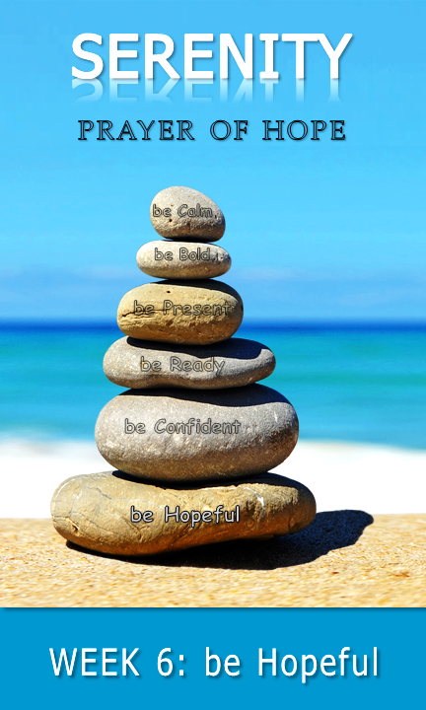
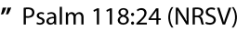

♦

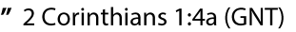

♦

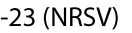

Pray
♦

daily Bible verses

With permission and in partnership, St. Thomas Lutheran Church has adapted this
study guide from Calvary Evangelical Lutheran Church’s (Clarkston, MI) series: 40 days of Courageous Prayer. It was inspired by Trevor Hudson’s book , The Serenity Prayer;
A simple Prayer to Enrich Your Life,Rick Warren’s 40DAYS campaigns,
and Rich Milheim’s FAITHS

be Hopeful | that I may be reasonably happy in this life and
supremely happy with Him forever in the next

share | part 2
share | part 1

◻
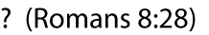
♦ ♦
read | part 2
read | part 1
♦
talk | part 2
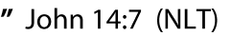
talk | part 1
♦
♦

♦
♦




