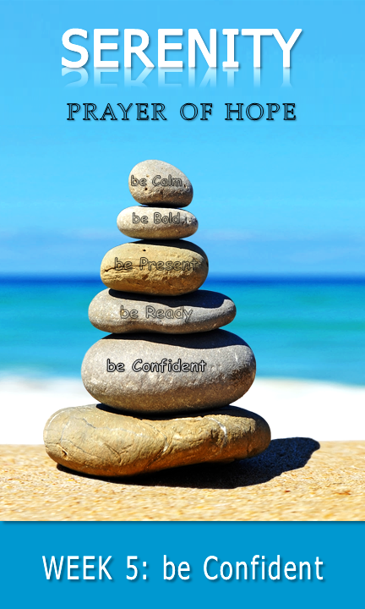
talk | part 2

♦

pray
♦
♦
♦

Daily Bible verses

With permission and in partnership, St. Thomas Lutheran Church has adapted this
study guide from Calvary Evangelical Lutheran Church’s (Clarkston, MI) series: 40 days of Courageous Prayer. It was inspired by Trevor Hudson’s book , The Serenity Prayer;
A simple Prayer to Enrich Your Life,Rick Warren’s 40DAYS campaigns,
and Rich Milheim’s FAITHS

share | part 1
be Confident | trusting that He will make all things right if I surrender to His will;

♦

◻
♦
♦
read | part 1
♦

share | part 2
♦
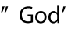
♦
♦

♦
talk | part 1
♦

♦
read | part 2

